ОТКРЫТОЕ АКЦИОНЕРНОЕ ОБЩЕСТВО
СЛОНИМСКИЙ КАРТОННО-БУМАЖНЫЙ ЗАВОД
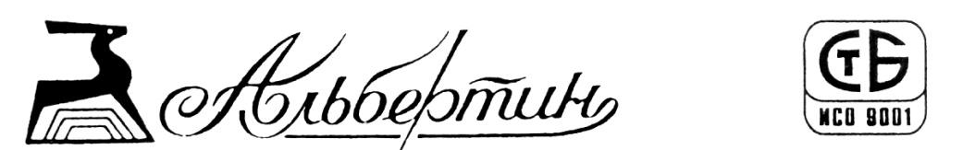
Беларусь Belarus
231793, Гродненской обл., г. Слоним 231793, Grodno region, Slonim
ул. Фабричная, 1 Fabrichnaya Str., 1
Телефакс (8-01562) 4-51-03 Fax (8-01562) 4-51-03
Телефоны: директор 4-51-04, 4-51-01 Telephones: director 4-51-04, 4-51-01
маркетинг 4-51-33, 4-51-08 marketing 4-51-33, 4-51-08
сбыт 4-51-10, 4-51-25 sales 4-51-10, 4-51-25
снабжение 4-51-09, 4-51-32 supply 4-51-09, 4-51-32
Адрес электронной почты: marketing@albertin.by e-mail: marketing@albertin.by
Сайт: www.albertin.by

№______________
На __________ от ____________

Сommercial proposal

JSC “Slonim cardboard-paper plant “ALBERTIN”

Joint-stock company «Slonim cardboard-paper plant «Albertin» is one of the largest pulp and paper industry of the Republic of Belarus.
231793 Grodno region, Slonim, Fabrichnaya Str., 1
Tel./Fax +3751562 45108, +3751562 45133 ; e-mail: marketing@albertin.by, website: www.albertin.by
Products with the brand name "Albertin" is widely known both in domestic and foreign markets.
We are writing to you with a request for assistance in the promotion of our products and the search for foreign partners.
Basic goods sold for export: cardboard, waterproof cardboard, testliner, fluting, paper basis for a toilet paper, paper basis for manufacturing napkins, towels, toilet paper.
We have the opportunity to offer the following types of cardboard:
№ | Name of goods | GTIN | Format, mm | Price in Euro per 1 ton on terms FCA Slonim
1 | Fluting (Corrugating paper. Scope – for flat layers of corrugated cardboard. Mark «B-2» - density 100, 112 g/m² ) | 4805 19 900 0 | On the basis of the full width of the machine-cut 2520-2620 mm. | 490
2 | Fluting (Corrugating paper. Scope – for flat layers of corrugated cardboard. Mark «B-3» - density 112, 125 g/m²) | 4805 19 900 0 | On the basis of the full width of the machine-cut 2520-2620 mm. | 485
3 | Testliner (Cardboard for flat layers of corrugated cardboard “K-3” reeled. Designed for flat layers of corrugated cardboard. Density – 140, 150 g/m²) | 4805 24 000 0 | On the basis of the full width of the machine-cut 2520-2620 mm. | 500
4 | Cardboard mark " KG " role, thickness 0.5-0.8 mm | 4805 93 200 0 | On the basis of the full width of the machine-cut  1720 mm-1820 mm. | 515
5 | Cardboard mark " KGS " role, thickness 0.5-0.8 mm | 4805 93 200 0 | On the basis of the full width of the machine-cut  1720 mm-1820 mm. | 505
6 | Cardboard «KT» role, sheet, thickness 0.5-0.8 mm. | 4805 93 200 0 | On the basis of the full width of the machine-cut – 1780 mm. | role – 515  sheet - 530

The technical characteristics of this product can be found on our website: www.albertin.by.
If you are interested, we are always ready to provide you with samples of the offered products in A-4 format.
Have any questions? Contact us: +375 1562 45133
+375 1562 45108
+37529 3443522 Viber, WhatsApp
E-mail: marketing@albertin.by

Our experts will be happy to answer all your questions.

Director General N. V. Antonik

